
FINAL Exam – Computer Vision 2024

Part 1: Optical Flow

Question 1 (1 point – 5 mn): What is the direction in the image along which optical flow cannot be reliably estimated?

ANSWER: The optical flow cannot be reliable estimated along the edges (perpendicular to the gradient direction). This is because the brightness constancy constraint involves the dot product between the image gradient rI and the optical flow u, rI . u + It = 0, which gives no equation on u when u and rI are orthogonal.

Question 2 (2 points – 10 mn): Given the brightness constancy equations:
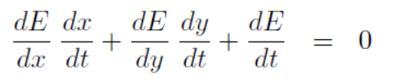
Explain intuitively what each of the five derivatives in the brightness constancy equation measures.

ANSWER:
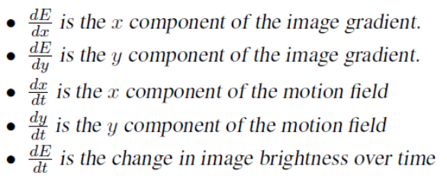

Question 3 (1 point – 5 mn): Give two different concise phenomena in the physical world that will invalidate the brightness constancy equation.

ANSWER: Barber pole, spinning Lambertian sphere, occlusions, specular highlights on a glossy surface.

Question 4 (2 points – 10 mn): What is the aperture problem, and how does it relate to the previous equation?

ANSWER: The aperture problem refers to the fact that motion estimation is highly ambiguous when the observation window is very small. In other words, the aperture problem is the ambiguity in the direction of the motion field along an isobrightness contour when a small image patch is being observed during motion. Only the component of the motion field along the image intensity brightness can be determined. The orthogonal component is entirely unconstrained. This can be seen in the previous equation which is a single scalar equation with two unknowns.

Question 5 (2 points – 10 mn): Suppose that the camera only translates, that you know the direction of translation, and that the rest of the world is stationary. Explain how you would use this knowledge to address the aperture problem.

ANSWER: The knowledge of the direction of translation could be used as an additional constraint on the motion field to give us 2 additional equations with two unknowns.

Question 6 (1 point – 5 mn): Optical flow estimation is problematic when:

ANSWER:
a. in homogeneous image areas. ѵ
b. in textured image areas. ѵ
c. at image edges.
d. at the boundaries of moving objects. ѵ

Question 7 (1 point – 5 mn): What can we say about image (c) ? and about image (b) versus image (a) ?
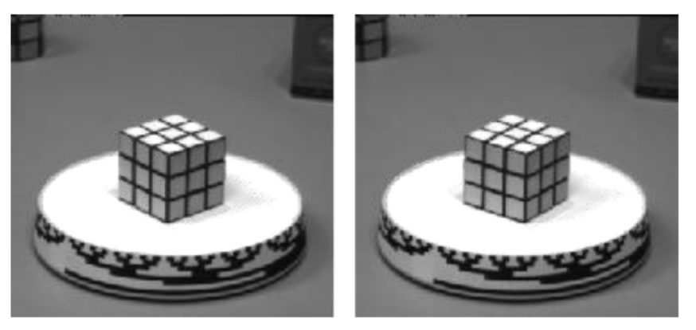
(a) time t (b) time t+1
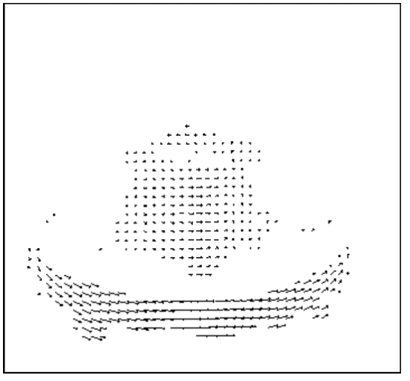
(c) the size of this image has been zoomed to make the interpretation easier.

ANSWER: It results from a small rotation around the vertical direction of the foreground object. The motion flow of the rotating white area is null as there is no intensity gradient. The optical flow of the cube is different of those of the rotating table due to its geometrical shape and of its black patterns.

Question 8 (2 point – 5 mn): What can we say about image (f) ? and about image (e) versus image (d) ? Be as precise as possible in your explanations.

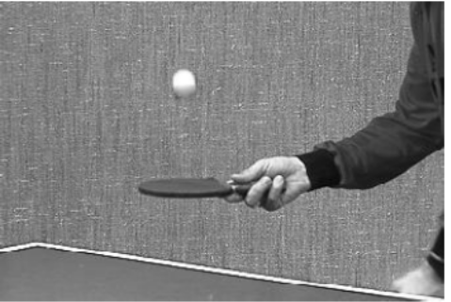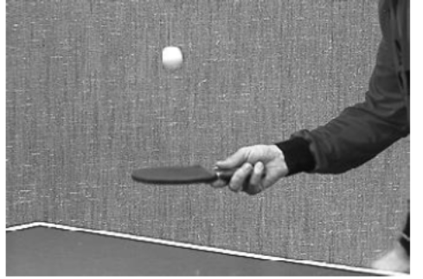
(d) time t (e) time t+1
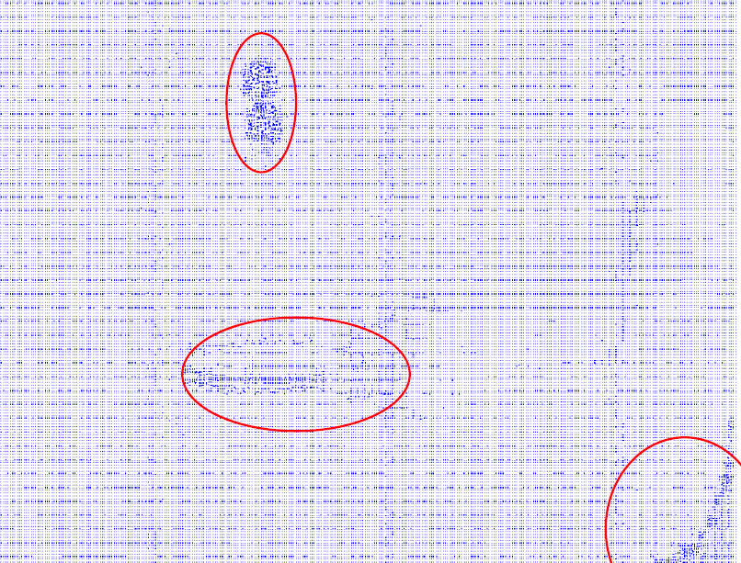
(f) the size of this image has been zoomed to make the interpretation easier.

ANSWER: It illustrates three main motion features in the scene (one translation of the ball in the vertical direction, one translation of the table tennis racket in the horizontal direction, and another more complex motion for the human harm). There is a little translation of the camera, but this motion is not significant, it can be considered as noise.

Part 2: Stereo and Epipolar Geometry

Figure below shows a pair of stereo images that have been captured using a pair of calibrated cameras.
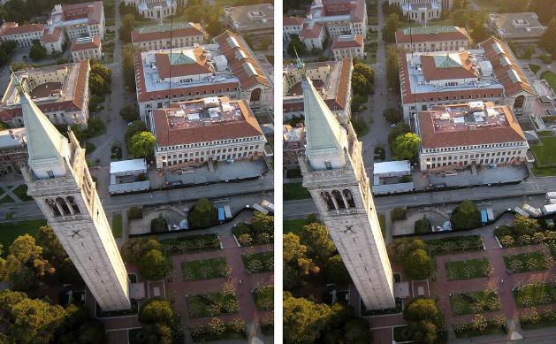

Question 9 (2 points – 10 mn): Explain how you could use the pair of images in this figure to calculate the distances from the camera of the surface features that appear in the scene.

ANSWER: knowledge question, see lecture notes

Given two ideal pinhole cameras where:
• the baseline of the two cameras is parallel to their scanlines,
• the optical axes of the two cameras intersect to form an angle of 90 degrees,
• the two centers of projection are at equal distances from the intersection of the optical axis,
• the field of view of each camera is 90 degrees.

Question 10 (2 points – 10 mn): Draw the epipoles and a few epipolar lines.

ANSWER:

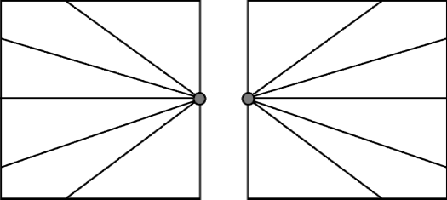

Question 11 (1 point – 5 mn): Under what conditions the essential matrix is identical to the fundamental matrix?

ANSWER: E = M_{r}^{−T} E M_{l}⁻¹. In other words, when the pixels expressed in camera coordinates are exactly the same as those expressed in pixel coordinates.

Question 12 (1 point – 5 mn): If E is the essential matrix returned by the 8-point algorithm, what do the solutions to the following two systems represent: E x_{l} = 0 and E^{T} x_{r} = 0.

ANSWER: The right and left epipoles, respectively. Consider E x = 0. The epipolar constraint can be expressed as follows: p_{r}^{T} E p_{l} = 0. When this equation hold, we know that p_{l} and p_{r} lie on corresponding epipolar lines. But consider a p_{r} such that E^{T} pr = 0 already. This suggests that no matter what p_{l} I choose, p_{r} must lie on a corresponding epipolar line. This is only true for one unique p_{r}, a point through which all epipolar lines must pass. That point is the right epipole. The argument is similar for the left epipole.

Part 3: Structure From Motion (SFM)

Suppose we perform SFM in an environment with N stationary point features, of which no four are coplanar. Suppose further that the absolute location of k static features is known, whereas the location of N − k is unknown.

Question 13 (2 points – 10 mn): For m = 10 camera images, what is the minimum value of k that enables us to reconstruct the absolute location of all features?

ANSWER: The answer is simple: k = 6 points are usually sufficient to localize each camera (12 parameters to recover, related to intrinsic and extrinsic parameters). k = 5 points would be insufficient since the entire structure could be rotated round the axis defined by these two points.
As a footnote, there might exist configurations under which even k = 3 points provide ambiguities. For example, this is may happen when two points are equidistant to a third, and the camera is positioned exactly on the plane that separates those two points. Then there is a discrete ambiguity. But these cases are rare...

Question 14 (1 point – 5 mn): Suppose we add a moving feature to the environment. Can we detect which feature moves? If yes, argue how. If no, provide a counterexample.

ANSWER: It’s actually possible to make a feature look stationary by moving in proportion to the camera motion. Here’s how you show this: pick a point feature in your environment, and hold your hand so this feature becomes occluded. Then move your head and your hand, maintaining the occlusion of this point feature. If you do this really carefully with a point-sized occluder, the resulting occluder will be indistinguishable from a static point in the environment.

